Superstore Sales Analysis Report
  - Introduction
In today’s data-driven world, businesses rely heavily on data analytics to make informed decisions and improve overall performance.
This project focuses on analysing the Superstore Sales dataset using Power BI to gain meaningful insights into sales performance, profitability, customer behaviour, and regional trends.
Objective
The primary objective of this project is to transform raw transactional data into an interactive and visually appealing dashboard that helps stakeholders understand key business metrics such as total sales, profit, order quantity, and growth over time. By leveraging data visualization techniques and advanced calculations like Year-to-Date (YTD) sales and Year-over-Year (YoY) growth, this project provides a comprehensive view of business performance.
The dashboard is designed with multiple analytical perspectives, including sales trends, product performance, discount impact, and regional analysis. These insights help identify top-performing products, loss-making areas, and the effect of pricing strategies on profitability. Additionally, shipping and delivery analysis provides an understanding of logistics efficiency and customer service performance.
Overall, this project demonstrates how Power BI can be used as a powerful tool to convert data into actionable insights, enabling businesses to optimize strategies, improve profitability, and support data-driven decision-making.
Dataset Description
The dataset used in this project is the Superstore Sales dataset, which contains transactional data related to a retail business. This dataset is widely used for data analysis and visualization projects to understand sales performance, profitability, and customer behaviour.
The data was sourced from Kaggle commonly used for learning Power BI and data analytics.
Dataset link: UrbanCart Superstore – Clean Retail Sales Dataset
It represents sales transactions across different regions, categories, and customer segments over multiple years.
The dataset consists of 21 columns and includes key information such as Order ID, Order Date, Ship Date, Customer details, Product details, Sales, Quantity, Discount, and Profit.
The columns in the dataset are:
• Order ID – Unique identifier for each order
• Order Date – Date when the order was placed
• Ship Date – Date when the order was shipped
• Ship Mode – Mode of shipment (First Class, Second Class, etc.)
• Customer ID – Unique ID for each customer
• Customer Name – Name of the customer
• Segment – Customer segment (Consumer, Corporate, Home Office)
• Country – Country of the customer
• City – City where the order was placed
• State – State of the customer
• Postal Code – Postal code of the location
• Region – Region (East, West, Central, South)
• Product ID – Unique ID for each product
• Category – Product category (Furniture, Office Supplies, Technology)
• Sub-Category – Product sub-category
• Product Name – Name of the product
• Sales – Total sales amount
• Quantity – Number of items sold
• Discount – Discount applied on the product
• Profit – Profit earned from the sale
This dataset provides a comprehensive view of business operations, enabling analysis of sales trends, product performance, regional distribution, and the impact of discounts on profitability.
Tools & Technologies
• Power BI
• Power Query
• DAX (Data Analysis Expressions)
• Excel Dataset
Data Cleaning & Transformation
Data is loaded into Power BI through Get data Option and Data is Transformed in Power Query
Data was cleaned using Power Query:
- Removed null values
- Corrected data types
- Removed duplicated rows
- Trimmed and cleaned Text
- Capitalized Each Word

Data Modelling
After Data Cleaning, data is loaded in Power BI through close &Apply Option and data modeling is done by creating Dimension Tables.
Star Schema Structure
Final Model
FACT TABLE (Main Table)
Superstore_Sales
- Order ID
- Order Date
- Ship Date
- Customer ID
- Product ID
- Sales
- Quantity
- Profit
- Discount

DIMENSION TABLES
Dim_Customer
- Customer ID
- Customer Name
- Segment
Dim_Product
- Product ID
- Product Name
- Category
- Sub-Category
Dim_Location
- Country
- State
- City
- Region
- Postal Code

Dim_Date
Create Date Table
Go to Model View → New Table
DateTable=
ADDCOLUMNS ((
CALENDAR(MIN('Superstore'[OrderDate]), MAX('Superstore'[OrderDate])),"Year”, YEAR([Date),"Month”, FORMAT([Date],"MMM"),"MonthNumber”, MONTH([Date]))
Then:
- Sort Month by Month Number
- Create relationship:
  - Date Table[Date] → Superstore[Order Date]
Dimension Tables Description
In this project, dimension tables were created as part of a star schema data model to organize and structure the dataset efficiently. These tables help in filtering, grouping, and analysing data from different perspectives.
The following dimension tables were created:
- Dim_Customer
The Dim_Customer table contains customer-related information. It includes columns such as Customer ID, Customer Name, and Segment. This table helps in analyzing customer behaviour and segment-wise sales performance. It allows comparison of sales between Consumer, Corporate, and Home Office segments.
- Dim_Product
The Dim_Product table stores product-related details including Product ID, Product Name, Category, and Sub-Category. This table is useful for analysing product performance, identifying top-selling products, and understanding which categories generate the highest revenue and profit.
- Dim_Location
The Dim_Location table contains geographical information such as Country, State, City, Region, and Postal Code. This table enables regional analysis, helping to identify high-performing regions and locations with low sales performance.
- Dim_Date
The Dim_Date table was created to support time-based analysis. It includes columns such as Date, Year, Month, and Month Number. This table is essential for performing time intelligence calculations like Year-to-Date (YTD) sales and Year-over-Year (YoY) growth. It also helps in analyzing trends over time.
These dimension tables are connected to the central fact table through relationships based on keys such as Customer ID, Product ID, and Date. The relationships are defined as one-to-many, where each dimension table filters the fact table.
By using dimension tables, the data model becomes more efficient, scalable, and easier to analyse. It also improves performance and ensures better organization of data for reporting and visualization.
A star schema model was created:
• Fact Table: Superstore Sales
• Dimension Tables: Customer, Product, Location, Date
Relationships were established using keys like Customer ID and Product ID.
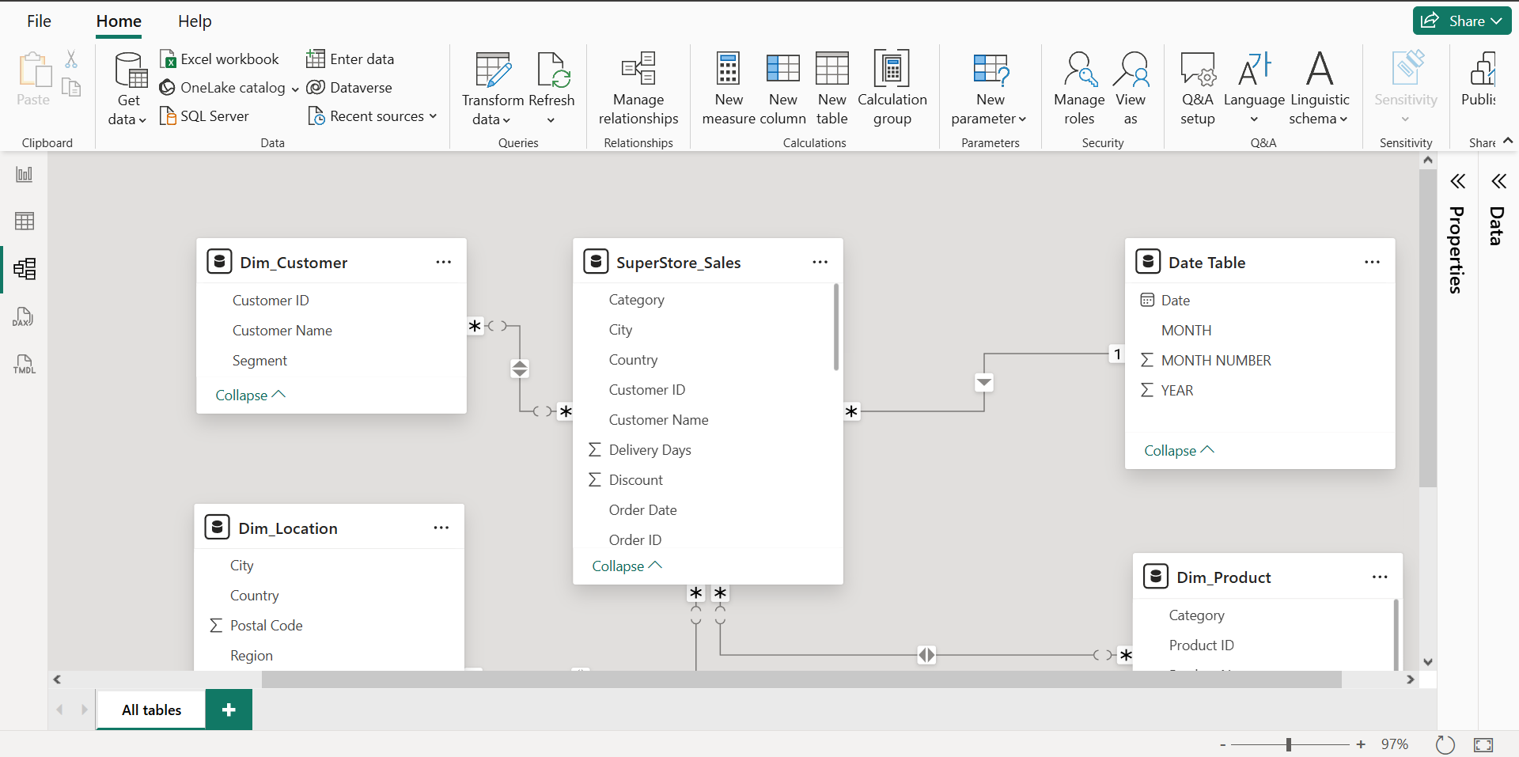

Create Measures (Core KPIs)
Go to Modelling → New Measure
Total Sales
Total Sales = SUM('Superstore'[Sales])
Total Profit
Total Profit = SUM('Superstore'[Profit])
Total Quantity
Total Quantity = SUM('Superstore'[Quantity])
Profit Margin
Profit Margin = DIVIDE ([Total Profit], [Total Sales])

Time Intelligence
YTD Sales
YTD Sales = TOTALYTD ([Total Sales], 'Date Table'[Date])

Previous Year Sales
PY Sales = CALCULATE ([Total Sales], SAMEPERIODLASTYEAR ('Date Table'[Date]))
YoY Growth
YoY Growth = [Total Sales] - [PY Sales]

Dashboard Overview
The Superstore Sales Dashboard is an interactive and visually structured report designed to provide a comprehensive overview of business performance.
The primary purpose of the dashboard is to transform raw data into meaningful insights that support data-driven decision-making. It enables users to quickly understand key performance indicators (KPIs), identify trends, and analyse business performance across different dimensions.
The dashboard consists of the following main pages:
- Sales Overview Dashboard
This page provides a high-level summary of business performance using KPI cards and visualizations. Key metrics such as
- Total Sales-1.10M
- Total Orders-5009
- Total Quantity-19K
- Year-to-Date (YTD) Sales-357.26K
- Monthly Sales Trend - X-axis-Month, Y-axis-Total sales - Line Chart.
- Sales by Category -X-axis-Category, Y-axis-Total Sales- Bar Chart.
- Top 5 Products - X-axis-Sub-Category, Y-axis-Total Sales- Column Chart.
- Sales by Segment- Legend-Segment, Values-Total Sales- Donut Chart.
- Slicers-Month, Category, Segment.

Sales Overview Insights
• Total Sales: 1.10M
• Technology category contributes highest revenue.
• Consumer segment dominates.
• Monthly trend shows higher sales at year-end.
• Top products significantly contribute to revenue.

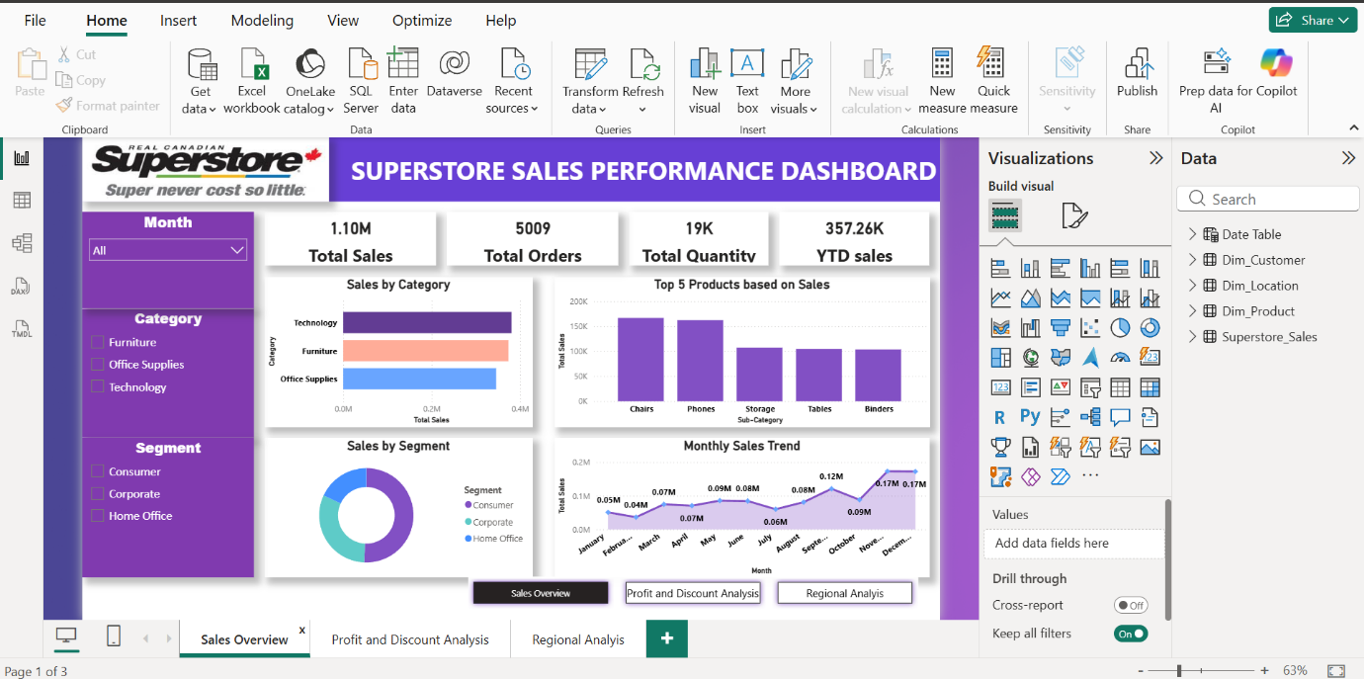

Profit and Discount Analysis
This page focuses on analyzing profitability and the impact of discounts on business performance. It includes visualizations such as
- Total Profit-132.52k.
- Profit Margin-12.05%.
- Profit by sub-category-X-axis-Sub- category, Y-axis-Sum of Profit.
- discount versus profit analysis-X-axis-Discount, Y-axis-Sum of Profit.
- Sum of sales and Sum profit by Year-X-axis-Year, Y-axis-Sales and Profit.
- Scatter plot -showing the relationship between sales and profit.
- Slicers-Year, Sub-Category.

Profit by Sub-Category
Identify loss-making products
- Use Column Chart
- Sort by Profit
Insight:
- Tables often show negative profit
Sales vs Profit (Scatter Chart)
- X -axis→ Profit
- Y -axis→ Sales
Discount Impact
- X-Axis → Discount
- Y-axis→ Profit
Insight:
Higher discount = Lower profit
This page helps identify loss-making products and highlights how excessive discounts negatively affect profitability.
Profit and Discount Analysis Insights
Profit Analysis
- Profit Margin is moderate (~12%)
- Some products generate loss despite high sales
- Profit varies significantly by category
Discount Analysis
- Discounts above 20% reduce profit
- High discount → High sales but low profit
- Optimal discount range: 0–20%

Profit & Discount Page
- Some sub-categories like Tables show losses.
- Higher discounts reduce profitability.
- Scatter plot shows high sales ≠ high profit.
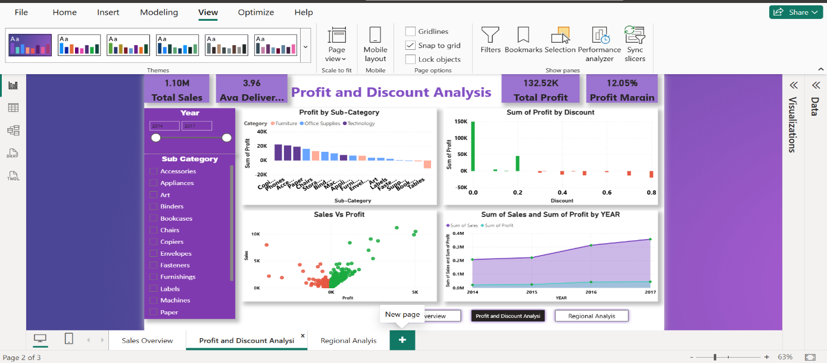

Regional Analysis Dashboard
Regional Analysis – Detailed Report
1. Overview
The Regional Analysis page provides insights into the geographical performance of the business. It helps in understanding how sales, categories, and delivery performance vary across different regions and states. This analysis enables identification of high-performing regions and areas that require improvement.

Visual 1: Sales by State (Map Visualization)
Description:
This visual represents sales distribution across different states using a map. Each state is marked with a bubble, where the size of the bubble indicates the total sales in that region.
Insights:
- States with larger bubbles generate higher revenue
- California is one of the top-performing states
- Western region shows strong sales concentration
Purpose:
This visual helps in identifying geographical areas with high and low sales performance.
Visual 2: Sales by Region
Description:
This chart compares total sales across four regions: West, East, Central, and South.
Insights:
- West region generates the highest sales
- East region follows with moderate performance
- Central and South regions show comparatively lower sales
Purpose:
To compare regional performance and identify top and underperforming regions.
Visual 3: Category by Region
Description:
This visual shows how different product categories (Furniture, Office Supplies, Technology) perform across regions.
Insights:
- Technology category performs well in all regions
- Furniture and Office Supplies vary by region
- Some regions have stronger category-specific performance
Purpose:
To understand category-wise demand across regions.
Visual 4: YoY Growth (KPI Card)
Description:
This KPI shows the Year-over-Year (YoY) growth in sales.
Insights:
- Positive YoY growth indicates business expansion
- A high percentage reflects strong improvement compared to previous year
Purpose:
To measure business growth over time.
Visual 5: Average Delivery Days by Ship Mode
Description:
This chart shows the average delivery time for different shipping modes such as First Class, Second Class, and Standard Class.
Insights:
- First Class has the fastest delivery time
- Standard Class takes the longest time
- Delivery efficiency varies across shipping methods
Purpose:
To evaluate logistics performance and shipping efficiency.
Key Insights
✔ West region is the top-performing region
✔ California contributes the highest sales
✔ Technology category drives revenue across regions
✔ Delivery time varies significantly by shipping mode
✔ Some regions show potential for growth
Business Recommendations
- Focus on expanding operations in high-performing regions
- Improve marketing strategies in low-performing regions
- Optimize shipping methods to reduce delivery time
- Promote high-demand categories like Technology
Conclusion
The Regional Analysis provides valuable insights into geographical performance and logistics efficiency. It helps businesses identify growth opportunities, optimize operations, and improve customer satisfaction.

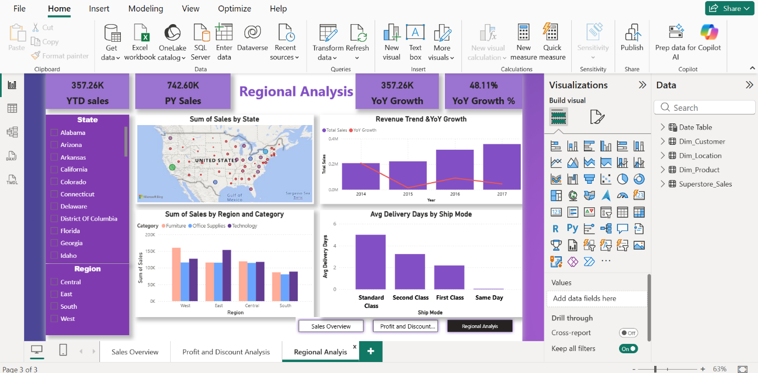

Overall Insights (With Reasons)
1. Strong Sales Performance
Insight:
The business shows strong overall sales performance with consistent growth over time.
Reason:
- High total sales value (1M+) indicates good market demand
- Monthly trend shows increasing sales, especially during year-end
- Multiple categories contribute to revenue
2. Technology Category Drives Revenue
Insight:
The Technology category generates the highest sales compared to other categories.
Reason:
- Higher customer demand for tech products
- Products in this category have higher pricing
- Consistent performance across regions

3. Consumer Segment is the Major Contributor
Insight:
The Consumer segment contributes the largest share of total sales.
Reason:
- Individual customers purchase more frequently
- Wider customer base compared to corporate segments
- Strong demand across all categories
4. Sales Show Seasonal Trends
Insight:
Sales peak during the end of the year.
Reason:
- Festival seasons and promotions increase demand
- Year-end discounts and offers drive purchases
- Higher customer spending during holidays
5. Few Products Drive Most Sales
Insight:
Top 5 products contribute a significant portion of total revenue.
Reason:
- High demand for specific popular products
- Better pricing or brand value
- Reflects Pareto principle (80/20 rule)
6. Profit is Not Equal to Sales
Insight:
Some products generate high sales but low or negative profit.
Reason:
- High discounts applied on those products
- High cost or low margins
- Inefficient pricing strategy
7. High Discounts Reduce Profit
Insight:
Discounts above 20% negatively impact profitability.

Reason:
- Reduced selling price lowers margins
- High discount → more sales but less profit
- Some cases result in losses
8. Loss-Making Sub-Categories Exist
Insight:
Certain sub-categories like Tables generate losses.
Reason:
- High discount rates
- Low profit margins
- High production or procurement cost
9. West Region Performs the Best
Insight:
The West region generates the highest sales.
Reason:
- Strong customer base.
- High-performing states like California.
- Better market penetration.
10. Regional Performance Varies
Insight:
Sales performance differs across regions.
Reason:
- Different customer preferences.
- Varying demand for product categories.
- Uneven market development.
11. Delivery Performance Varies by Ship Mode
Insight:
Delivery time differs significantly across shipping modes.
Reason:
- First Class → fastest delivery.
- Standard Class → slower but widely used.
- Cost vs speed trade-off.
12. Standard Class Has Higher Delivery Time
Insight:
Standard Class shipping takes the longest delivery time.
Reason:
- Cost-effective but slower logistics.
- Used for bulk shipments.
- Less priority handling.
13. Positive Year-over-Year (YoY) Growth
Insight:
The business shows a positive Year-over-Year (YoY) growth, indicating that sales have increased compared to the previous year.
Reason:
- Higher sales in the current year compared to last year.
- Increased customer demand and improved performance.
- Effective sales strategies and promotions.
14. Strong Business Growth Trend
Insight:
The YoY growth percentage (e.g., ~48%) reflects strong business expansion.
Reason:
- Growth in key categories like Technology.
- Improved performance in top regions (e.g., West.
- Increase in repeat customers and order volume.
15. Growth Driven by Key Factors
Insight:
The increase in YoY growth is mainly driven by specific categories and regions.
Reason:
- Technology category contributes major revenue.
- High-performing states like California boost sales.
- Seasonal demand increases total sales.
Business Recommendations
Based on the above insights, the following recommendations are suggested to improve business performance:

1.Optimize Discount Strategy
The company should limit excessive discounting, especially beyond 20%, as it negatively impacts profitability. Implementing controlled and targeted discount strategies can help maintain a balance between sales and profit.
2.Focus on High-Profit Products
Greater emphasis should be placed on promoting and selling high-margin products, particularly within the Technology category. Loss-making products should be reviewed and either repriced or discontinued.
3.Improve Underperforming Regions
Marketing efforts should be increased in low-performing regions such as Central and South to boost sales. Region-specific strategies can help address local customer preferences and improve performance.
4.Enhance Product Strategy
Identify top-performing products and ensure their availability and promotion. At the same time, analyse underperforming products to determine whether they require pricing adjustments or removal from the portfolio.
5.Improve Logistics and Delivery Efficiency
Efforts should be made to reduce delivery time, especially for Standard Class shipping. Optimizing logistics operations can improve customer satisfaction and retention.
6.Leverage Customer Segmentation
Since the Consumer segment drives the majority of sales, targeted marketing campaigns and loyalty programs should be implemented to retain and expand this customer base.
Conclusion
In conclusion, the dashboard provides valuable insights into sales, profit, and operational performance. By implementing the recommended strategies, the business can enhance profitability, improve efficiency, and achieve sustainable growth. The use of Power BI enables effective data visualization and supports better decision-making through interactive and dynamic reporting.

